

Polycom VVX 150 - Guide

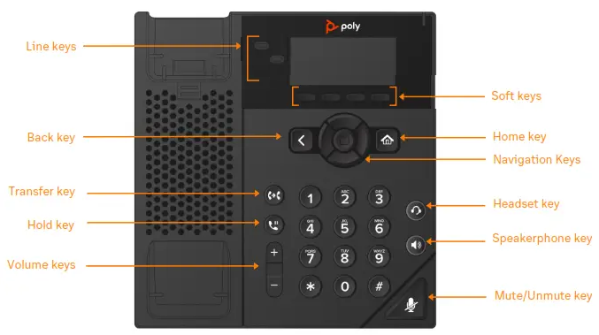

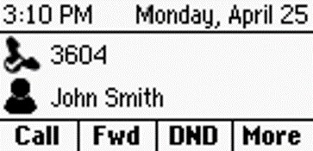 | Lines Screen  Displays Phone lines, Favorites, and conditional Soft keys.  Available anytime.
 | Home Screen  Displays Messages, Settings, and Information.  Available anytime.
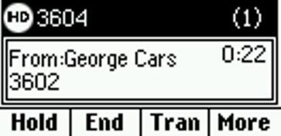 | Calls Screen  Displays all Active and Held calls.

Switch among Phone Screens
You can view any screen on your phone from other screens.

To switch between screens:
» Do one of the following:
- Press the Home key  to display the Home screen from the Lines, Calls or Active Call screen.
- Press the Lines soft key to access the Lines screen from the Calls or New Call Screen.
- Press the Calls soft key to access the Calls screen from the Lines screen.
- On VVX 150 phones, press the C > L soft key to display the Lines screen from the Calls screen.
- On VVX 150 phones, press the L > C soft key to display the Calls screen from the Lines screen.
Place Calls
You can only have one active call in progress on your phone.

To place a call:
» Do one of the following:
- Pick up the handset, press or , enter the phone number, and press Send.
- Enter the phone number, press Dial and pick up the handset, or press .
- From the Lines screen, press the Line key, enter the phone number, and select Send.
- From the Home screen, select New Call, enter the phone number, and press Send.
- Select a Favorite from the home screen.
- Select a contact from the Recent Calls and
Contact Directory.

Answer Calls
You can answer calls on your phone using the handset, speakerphone, or a headset.

To answer a call:
» Do one of the following:
- To answer with the speakerphone, press or press Answer soft key.
- To answer with the handset, pick up the handset.
- To answer with a headset, press .

End Calls
You can end active calls at any time. To end a held call, you must resume the call first.

To end an active call:
» Replace the handset in the cradle, press or , or press the End Call soft key.

To end a held call:
- Select the held call and press Resume.
- Press End Call.

Hold and Resume Calls
You can have multiple calls on hold and resume a call at any time.

To hold a call:
» Select the call and press the Hold soft key.

To resume a call
» Select the call and press the Resume soft key.

Transfer Calls
You can transfer calls to any contact.

To transfer a call:
- Press and hold the Transfer soft key.
- Choose Blind or Consultative. Consultative transfers allow you to speak to the person who will receive the call before transferring the call.
- Dial a number or choose a contact.
If you chose Blind, the call is transferred immediately.
If you chose Consultative, press the Transfer soft key after speaking with your contact.

Forward Calls
You can forward an incoming call to a contact or forward all incoming calls to a contact.

To forward an incoming call:
- On the Incoming Call screen, select

Forward.
- Enter your contact’s number and select

Forward.
To forward all incoming calls:
- On the Home screen, select Forward.
- If you have more than one line, select a line.
- Choose either Always, No Answer, or Busy.
- Enter a contact’s number and select Enable.
If you choose No Answer, you can enter the number of rings before the call is forwarded.

To disable call forwarding:
- Select Forward or press the Fwd soft key.
- If you have more than one line, select a line.
- Choose your forwarding type and select
Disable.

View Recent Calls
You can view recent placed, received, and missed calls.

To view recent calls:
» Navigate to Directories > Recent Calls.

View the Contact Directory
You can view and add contacts to the Contact Directory.

To view the Contact Directory:
» From the Home screen select Directories
>Contact Directory.

To add a contact to the Contact Directory:
- Navigate to Directories > Contact Directory
- In the Contact Directory, select Add.
- Enter the contact’s information and select

Save.
You can enter a number between 1 and 99 in the
Favorite Index field to make a contact a favorite.

Listen to Voicemail
When you have new voicemail messages, the red voicemail indicator will blink.

To listen to voicemail:
- At the dial tone, dial *95, or
- On the Home screen, select Messages.
- Select Message Center > Connect.
Enable Do Not Disturb
You can enable Do Not Disturb to prevent your phone from ringing and to send all incoming calls directly to voicemail.

To enable or disable Do Not Disturb:
» On the Home screen or Idle Screen, select
DND.

